SCHOOL

Trial WACE Examination, 2011

Question/Answer Booklet

MATHEMATICS SPECIALIST 3A/3B
SOLUTIONS

Section Two:

Calculator-assumed

Student Number: In figures

In words

Your name

Time allowed for this section
Reading time before commencing work: ten minutes
Working time for this section: one hundred minutes

Materials required/recommended for this section

To be provided by the supervisor
This Question/Answer Booklet
Formula Sheet (retained from Section One)

To be provided by the candidate
Standard items: pens, pencils, pencil sharpener, eraser, correction fluid/tape, ruler, highlighters

Special items: drawing instruments, templates, notes on two unfolded sheets of A4 paper, and up to three calculators satisfying the conditions set by the Curriculum Council for this examination.

Important note to candidates

No other items may be used in this section of the examination. It is your responsibility to ensure that you do not have any unauthorised notes or other items of a non-personal nature in the examination room. If you have any unauthorised material with you, hand it to the supervisor before reading any further.

Structure of this paper

Section | Number of questions available | Number of questions to be answered | Working time (minutes) | Marks available | Percentage of exam
Section One:  Calculator-free | 5 | 5 | 50 | 50 | 33
Section Two:  Calculator-assumed | 13 | 13 | 100 | 100 | 67
 |  |  | Total | 150 | 100

Instructions to candidates

- The rules for the conduct of Western Australian external examinations are detailed in the Year 12 Information Handbook 2011. Sitting this examination implies that you agree to abide by these rules.

- Write your answers in the spaces provided in this Question/Answer Booklet. Spare pages are included at the end of this booklet. They can be used for planning your responses and/or as additional space if required to continue an answer.
- Planning: If you use the spare pages for planning, indicate this clearly at the top of the page.
- Continuing an answer: If you need to use the space to continue an answer, indicate in the original answer space where the answer is continued, i.e. give the page number. Fill in the number of the question(s) that you are continuing to answer at the top of the page.

- Show all your working clearly. Your working should be in sufficient detail to allow your answers to be checked readily and for marks to be awarded for reasoning. Incorrect answers given without supporting reasoning cannot be allocated any marks. For any question or part question worth more than two marks, valid working or justification is required to receive full marks. If you repeat an answer to any question, ensure that you cancel the answer you do not wish to have marked.

- It is recommended that you do not use pencil, except in diagrams.

Section Two: Calculator-assumed (80 Marks)
This section has thirteen (13) questions. Answer all questions. Write your answers in the spaces provided.

Working time for this section is 100 minutes.

Question 6 (5 marks)
(a) Convert the polar coordinate 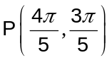 to Cartesian form, correct to 2 decimal places.
(2 marks)
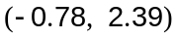

(b) Convert the polar equation 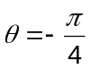 into Cartesian form. (1 mark)

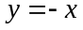

(c) Convert the Cartesian equation 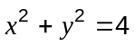 into polar form. (2 marks)
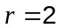

Question 7 (8 marks)
In the triangle below, 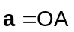, 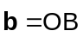, M is the midpoint of OA and P is a point on AB such that 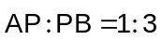.
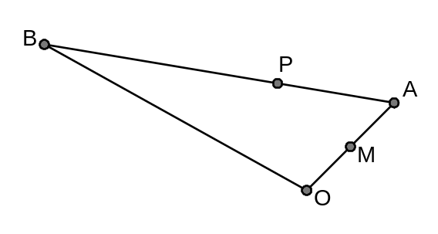
(a) Express each of the following in terms of a and /or b.

(i)  (1 mark)
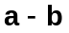

(ii)  (2 marks)
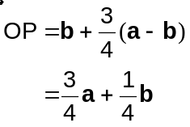

(iii) 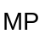 (2 marks)
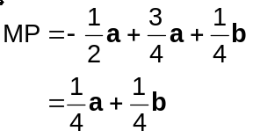

(b) If 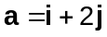 and 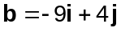, determine 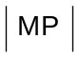. (3 marks)
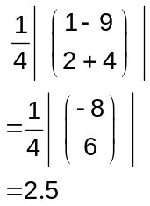

Question 8 (7 marks)
The top of a vertical radio mast stands 35 m above the surrounding level ground. From point A which is on the ground and due east of the base of the mast, the angle of elevation of the top of the mast is 50°. From another point on the ground, C, which is 60 m away from A, the bearing of the base of the mast is 024°.

Calculate the angle of elevation of the top of the mast from C.

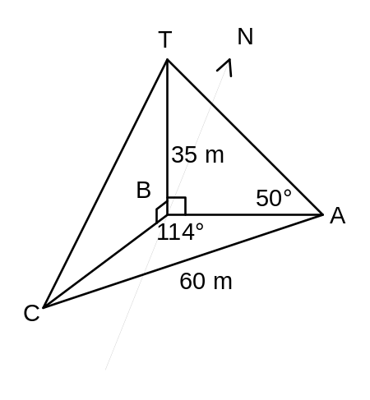

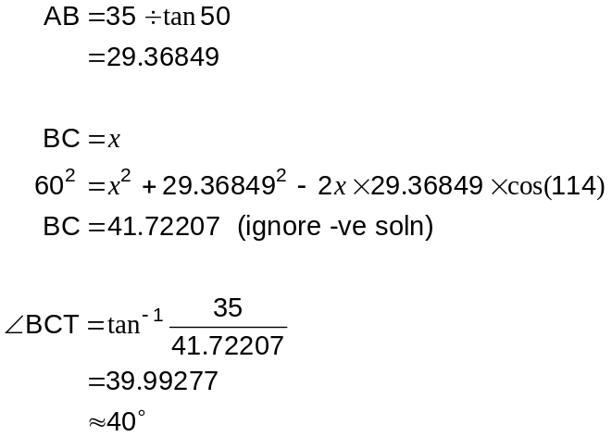

Question 9 (8 marks)
After a period of rain, the volume of water in a storage tank, kL, increases according to the rule 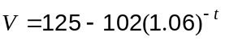 for 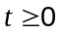, where is time in hours.

(a) What is the initial volume of water in the tank? (1 mark)
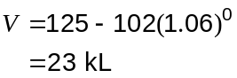

(b) Sketch the graph of this relationship on the axes below. (2 marks)
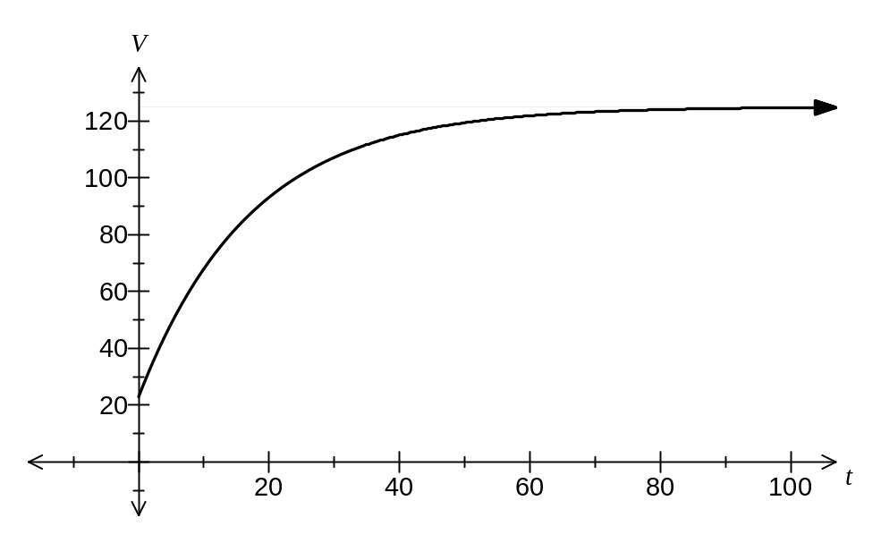

(c) According to the rule, what is the maximum volume of water that the tank can hold?
(2 marks)
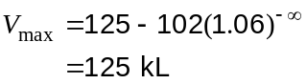

(d) How long, to the nearest hour, will it take for the tank to fill to within 5% of its maximum capacity? (3 marks)
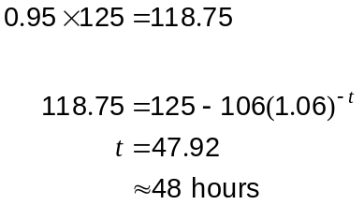

Question 10 (7 marks)
The two functions f and g are defined by 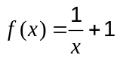 and 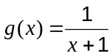.

(a) Find and simplify an expression for 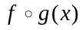. (2 marks)
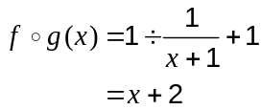

(b) State the domain of . (2 marks)

(c) Sketch the graph of . (3 marks)
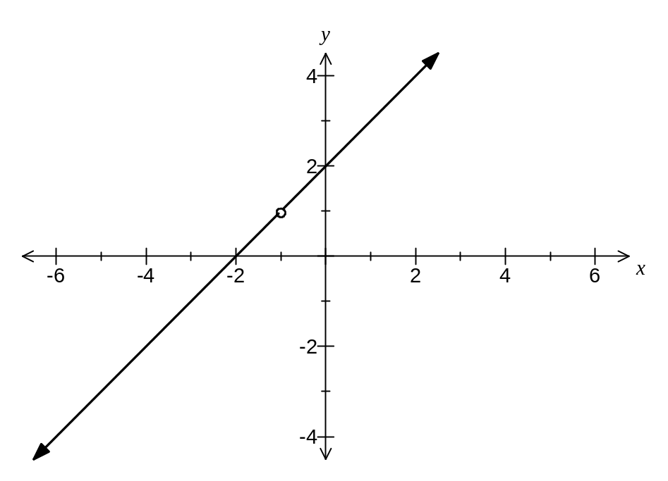

Question 11 (10 marks)
(a) Using the formula 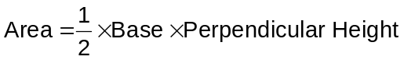, show that the area of a triangle with two sides of lengths and , and included angle of is given by 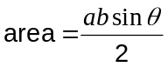.

(2 marks)
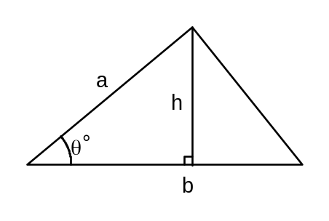

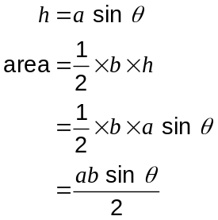

(b) A triangle is inscribed in a circle, centre O, with minor arcs AB, BC and CA having lengths 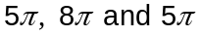 cm respectively.
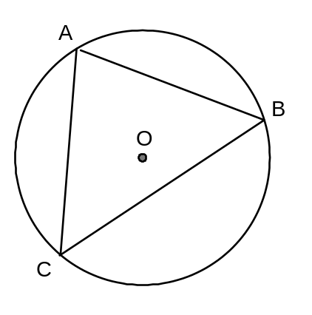

(i) Show that the radius of the circle is 9 cm. (2 marks)

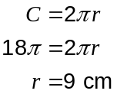

(ii) Show that 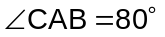. (3 marks)

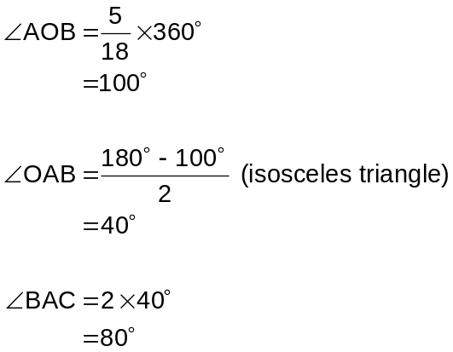

(iii) Find the area of triangle ABC. (3 marks)
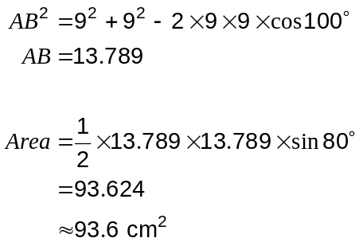

Question 12 (7 marks)
The function 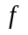 is defined by 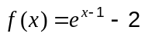.

(a) Draw the graph of 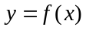 on the axes below. (2 marks)
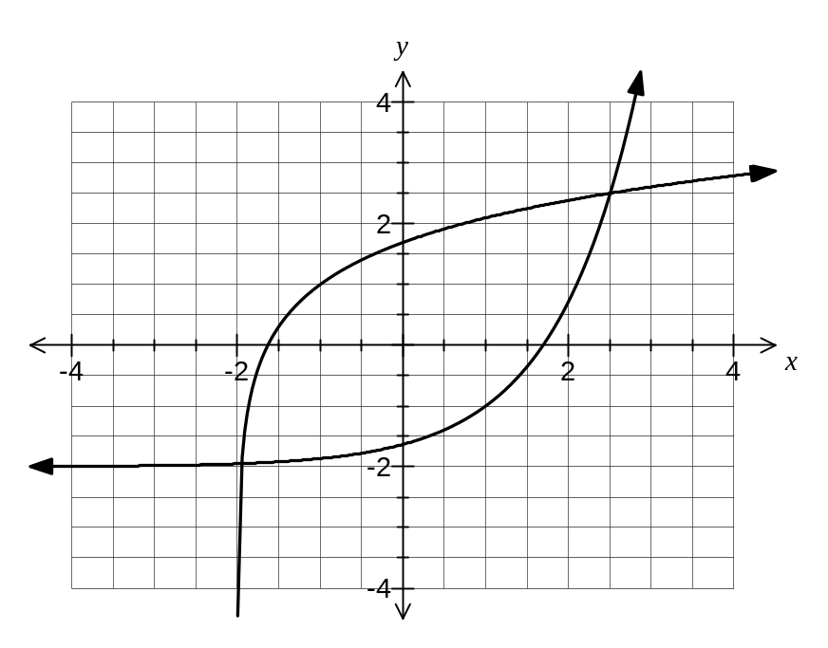
(b) State the domain and range of . (2 marks)

Domain of 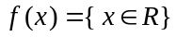

Range of 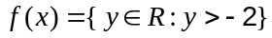

(c) Add the graph of 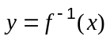, the inverse of , to the axes above. (2 marks)

(d) State the domain and range of 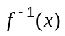. (1 mark)

Domain of 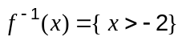

Range of 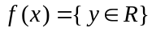

Question 13 (7 marks)
A boat is motoring at 18 km/h on a bearing of 245°. To an observer on board the boat, the wind appears to be blowing at 28 km/h from due west.

If the boat turned through 180° and increased its speed to 20 km/h, find the new apparent wind speed and direction.
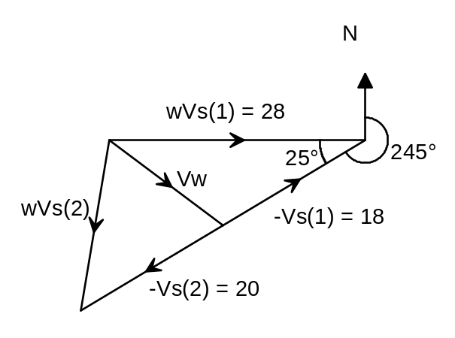

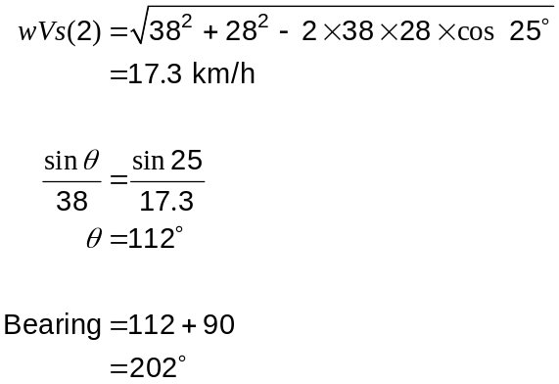

Question 14 (11 marks)
Two robots can be programmed to travel in a straight line with constant velocity.

Relative to an origin O, robot A leaves position 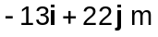 and travels with velocity 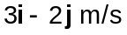.

One second later, robot B starts from position 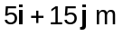 and travels with velocity 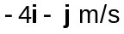.

(a) Calculate the position and velocity of robot A relative to robot B at the instant robot B starts and hence explain why the robots will not collide. (5 marks)
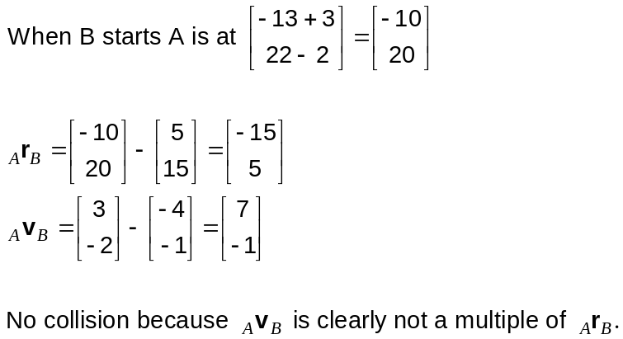

(b) Determine the minimum distance between the two robots after they both start moving.
(6 marks)

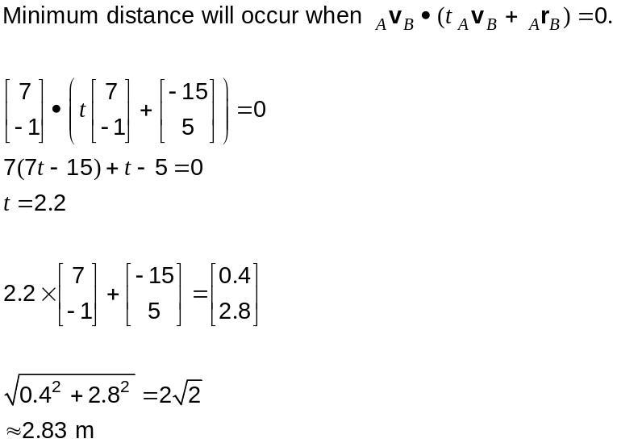

Question 15 (5 marks)
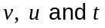 are related by the equations 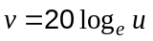 and 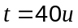, for 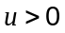.

(a) Find expressions for 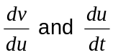 and hence use the chain rule to find 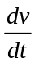 in terms of .
(3 marks)
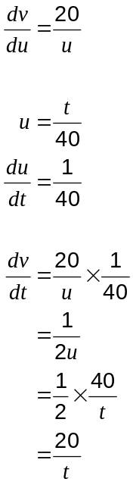

(b) Sketch the graph of against for 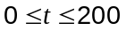. (2 marks)

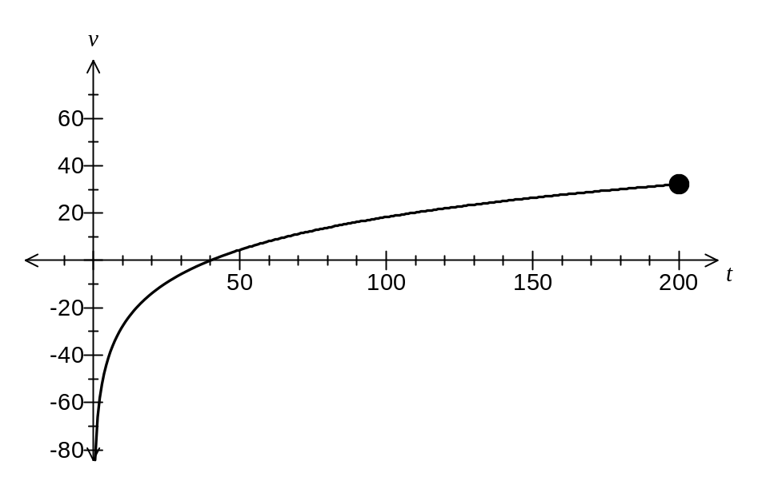

Question 16 (9 marks)
The function is continuous on 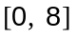 and is defined by 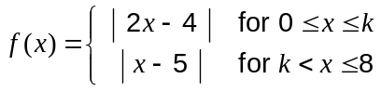

(a) Find the value of . (3 marks)
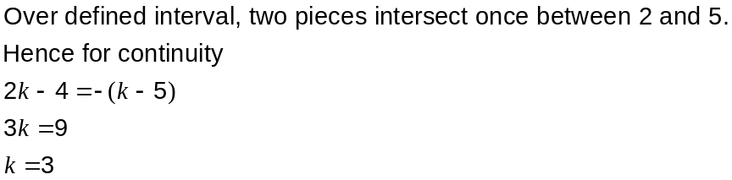

(b) Sketch the graph of . (3 marks)
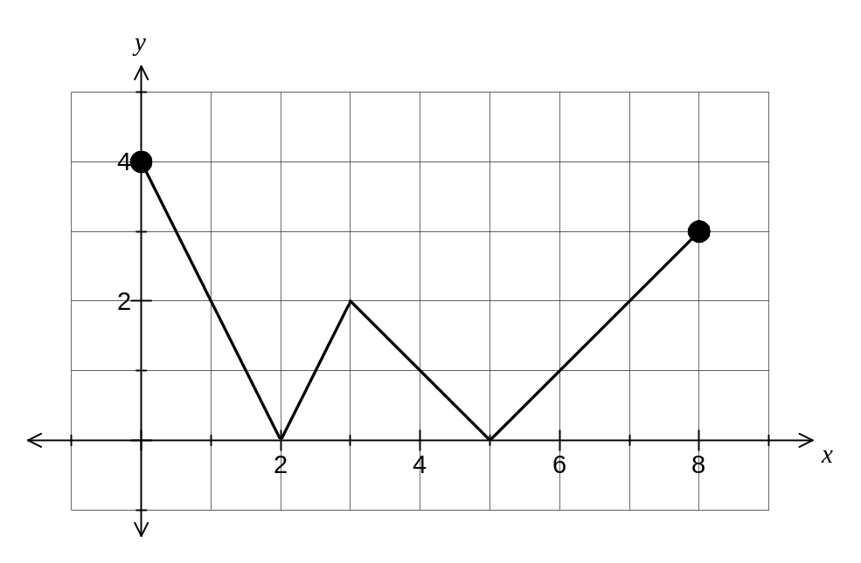

(c) Discuss the differentiability of on . (3 marks)

is differentiable everywhere except when 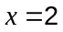, 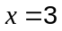 and 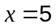.

At all these values of , there is an obvious cusp, indicating that 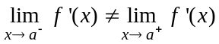.

Question 17 (11 marks)
(a)
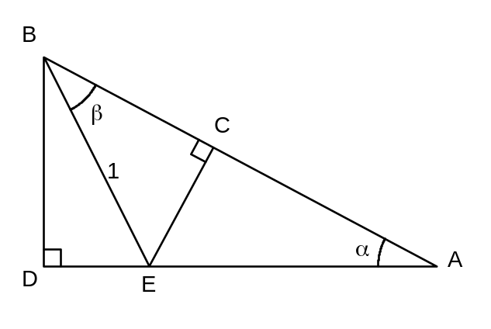

(i) Explain why 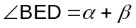 and hence show that 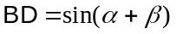. (3 marks)
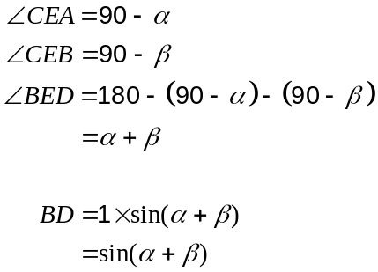

(ii) Given that 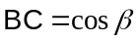 and 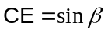, use triangle ACE to show that 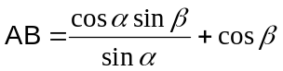. (2 marks)
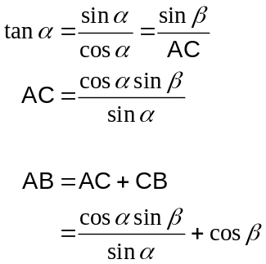

(iii) Use triangle ABD to show that . (3 marks)
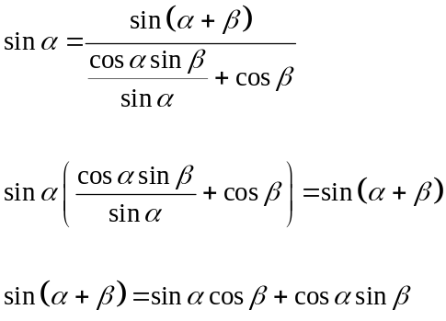

(b) Show use of the above result to find an exact value for 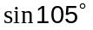. (3 marks)

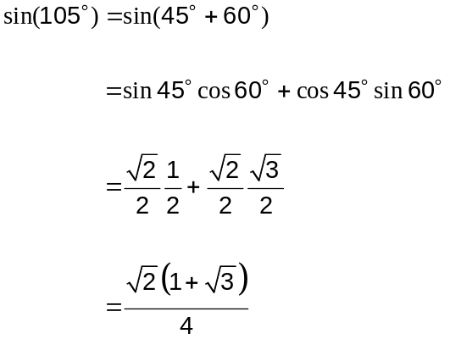

Question 18 (5 marks)
(a) Use your calculator to evaluate 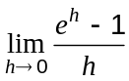. (1 mark)

1

(b) Using your result from part (a), show that the derivative of 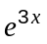 from first principles is 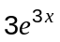.
(4 marks)
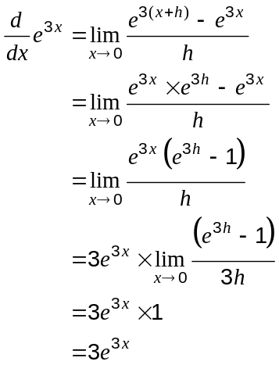

Additional working space

Question number: _________

This examination paper may be freely copied, or communicated on an intranet, for non-commercial purposes within educational institutes that have purchased the paper from WA Examination Papers provided that WA Examination Papers is acknowledged as the copyright owner. Teachers within purchasing schools may change the paper provided that WA Examination Paper's moral rights are not infringed.

Copying or communication for any other purposes can only be done within the terms of the Copyright Act or with prior written permission of WA Examination papers.

Published by WA Examination Papers
PO Box 445 Claremont WA 6910

